Donations Needed

* Clothing (Adult, Teen & Baby)
* Toiletries
* Canned/Dry Foods, Pastas & Sauces, Cereals

Volunteers Needed to Teach:

* Computer Access
* Basic Computer Classes
* Career/

Personal Development Classes

* Bible Study & Prayer

# We are here for you, for your family and for your community.

Open Tuesdays & Wednesdays 10:00am – 1:00pm

& for Emergency Pickups by Appointment Only

**Dart Bus Route 11 Washington Street**

HOPE Closet

201 Hawthorne Drive

Wilmington, DE 19802

302 401-8333

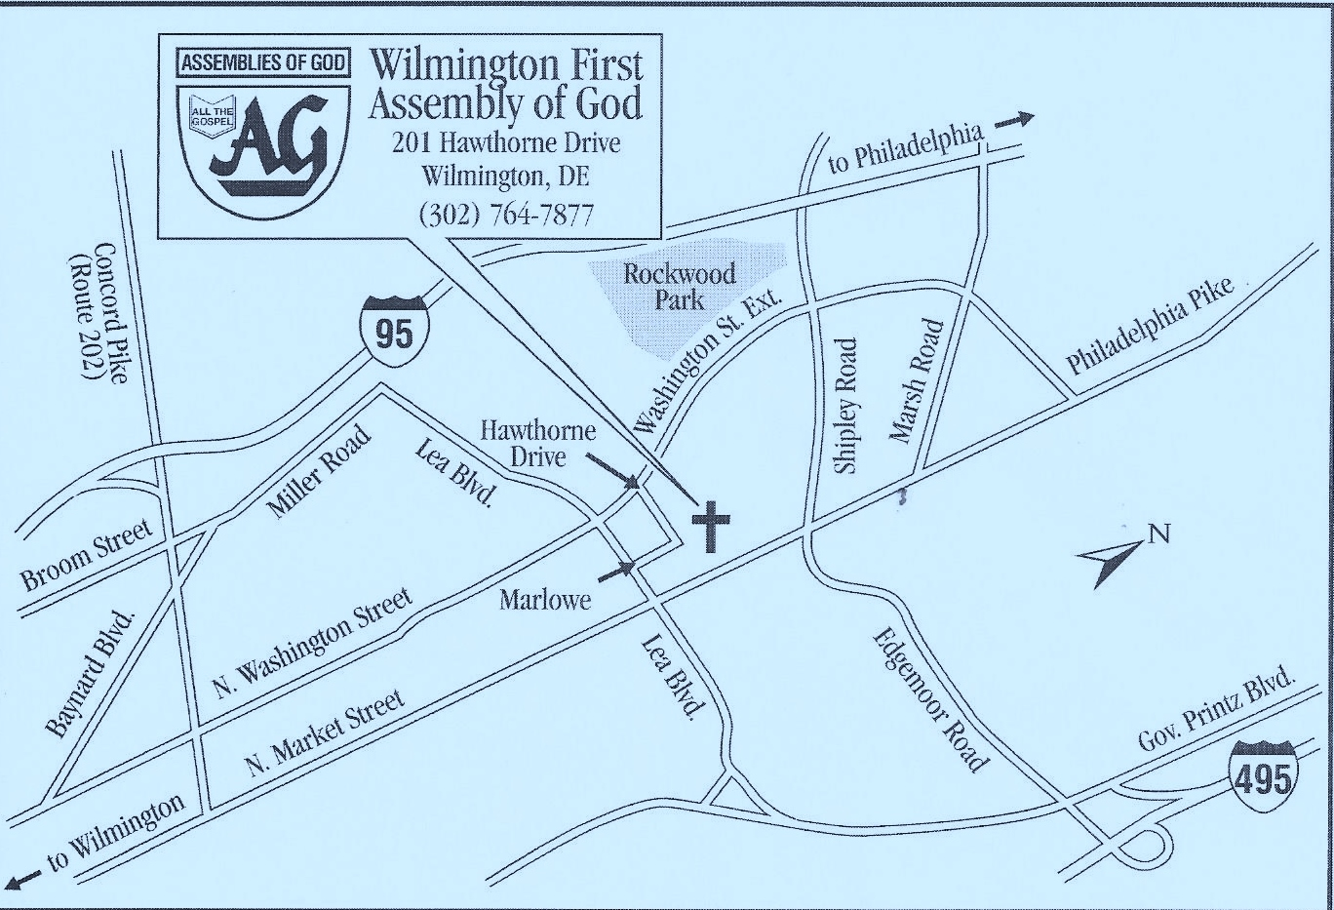

Brought to you by Wilmington First Assembly (WFA) & SPEAK!

Visit us at [www.WFA.org](http://www.WFA.org) & [www.Speak4TWC.org](http://www.Speak4TWC.org)

C:\Users\Lyn\AppData\Local\Microsoft\Windows\Temporary Internet Files\Content.IE5\GOMLFRM3\MC900038626[1].wmf

C:\Users\Lyn\AppData\Local\Microsoft\Windows\Temporary Internet Files\Content.IE5\27MH87XS\MC900370736[2].wmf

C:\Users\Lyn\AppData\Local\Microsoft\Windows\Temporary Internet Files\Content.IE5\GOMLFRM3\MC900439939[1].wmf

C:\Users\Lyn\AppData\Local\Microsoft\Windows\Temporary Internet Files\Content.IE5\PRI6E9S6\MC900370442[1].wmf

C:\Program Files (x86)\Microsoft Office\MEDIA\CAGCAT10\j0195384.wmf

